- How can you be at rest and also moving about 107,000 km/h at the same time?

- Does the speedometer in a car measure the car’s average speed or instantaneous speed? Explain your choice using the definition of each.

- Which is a vector quantity: speed or velocity? Explain why your choice is correct.

- What two driving controls on a car cause a change in speed? What driving control causes only a change in velocity?

Solve all physics problems according to the following four steps.
Drawing a simple sketch of the problem may help.

- Knowns - List all the known variables.
- Unknowns - List the unknown variable.
- Equation -
  - Write the basic equation needed.
  - Rearrange the equation, if necessary, with the unknown variable to the left.
- Solve -
  - Substitute the known values (numbers and units) for the letters in the equation.
  - Cancel units, if possible.
  - Do the arithmetic.
  - The answer should contain correct units and no fractions.

- Car A is heading East at 25 m/s and car B is also heading East at 25 m/s. What is car B’s velocity relative to car A? How would the passenger in Car A describe Car B’s motion? 0 m/s
- Car G is heading East at 25 m/s and Car X is heading East at 10 m/s. What is car G’s velocity relative to car X? How would the passenger in Car X describe Car G’s motion? 15 m/s east

- Car D is heading East at 25 m/s and Car T is heading West at 10 m/s. What is car T’s velocity relative to car D? How would the passenger in Car D describe Car T’s motion? 35 m/s west

- What is the speed of a truck that travels 20 km in 10 minutes?
2 km/min
- What is the distance traveled by a car that moves at a constant speed of 30 km/h for 3 hours?
90 km
- How long would it take a car to travel a distance of 75 km at a speed of 25 km/h?
3 h
- What is the total displacement of a motorcycle with a velocity of 2 m/s south in 50 s?
100 m
- What is the velocity of a bike that travels 2 miles west in 20 minutes?
0.1 mi/min west
- Light from the sun reaches the earth in 498 s. If the sun is 1.494 x 10¹¹ m from the earth, how fast (m/s) does light travel in space? ` 3.00 x 10⁸ m/s

- A bullet is fired at 660 m/s and strikes a target 200 meters away. What is the duration of the bullet’s flight? 0.30 s

- How far would an object move in 20 seconds if it were traveling at a constant speed of 63 meters per second? 1260 m

- A football travels 25 meters in 2.6 seconds. What is the speed of the football? 9.6 m/s

- A motorist travels 406 kilometers during a 7 hour period. What was the average speed?
58 km/h
- During a canoe race, a camper paddles 406 meters in 70 seconds. What is the average speed?
5.8 m/s
- A bullet shot from a rifle with a speed of 720 m/s. How far will the bullet travel in 2.3 s?
1660 m
- A rocket launched into outer space travels 2.4 x 10⁵ kilometers during the first 6.2 hours after the launch. What is the average speed of the rocket? 38,700 km/h

- An electron travels through a vacuum tube 2 centimeters long in 0.000016 seconds. What is the average speed of the electron? 130,000 cm/s

- The distance from home plate to the pitcher’s mound is 60.5 feet. If John Smoltz throws his 95 mi/h fastball, how many seconds does the batter have to swing at the ball after it is released? 0.43 s
- What is the velocity of a car traveling north on I-75 if it takes 2 hours to reach Chattanooga (120 miles)? 60 mi/h North

- What is the velocity of a student that takes 5 minutes to walk to Hillgrove from home? The student lives 0.5 mile north of Hillgrove. 0.1 mi/min South

- During a 400 meter run at a track meet the runner in lane 1 will start and finish at the same point. If it takes 58 seconds for her to run the race what is her velocity? No velocity

- (a) What is the displacement of a cyclist during a 0.50 hour ride if his average velocity was 1.00 km/h west? (b) Did the cyclist actually travel more, less, or the same total distance as his displacement. Explain your answer 0.5 km West; more or same

- Danny’s total displacement during the school day was 25.38 meters towards the gym. His average velocity was 3.54 m/h towards the gym. How long is Danny’s school day? 7.17 h

- Ender Inciarte throws a baseball from the outfield to home plate and nails a runner trying to score. If Ender was 106.7 meters from home plate and the throw takes 2.75 seconds to get there, what was the velocity of Ender’s throw in miles per hour? 86.6 mi/h toward home (38.8 m/s)

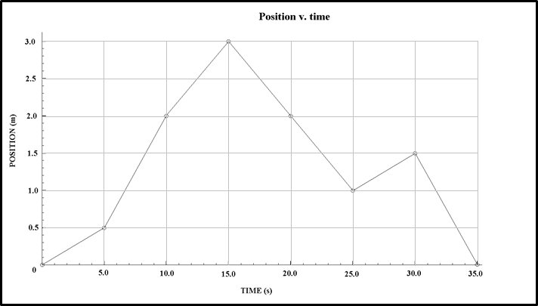
- Determine the velocity for each segment of the graph. Describe the motion that may have caused the graph.
B
A
C
D
E
F
G

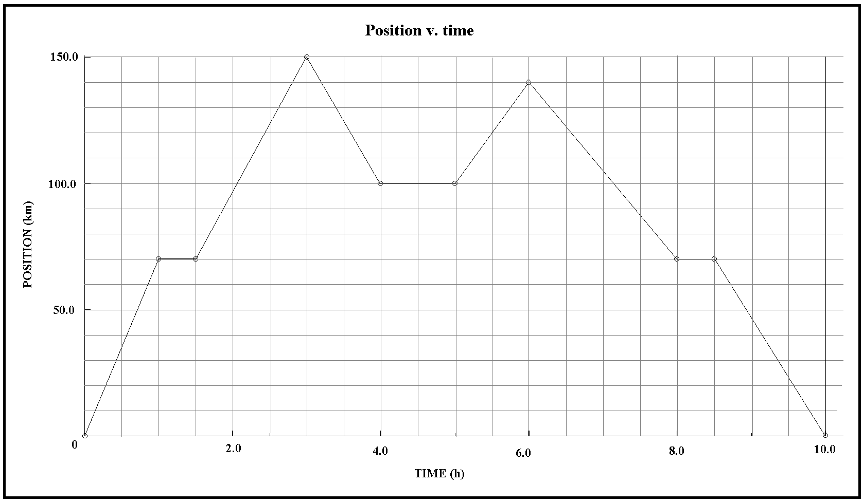
- Determine the velocity for each segment of the graph. Describe the motion that may have caused the graph.
A
B
I
H
G
F
E
D
C

- Plot the position v. time graph that represents the following story:

Sally the salamander is 75 inches from the steam. She speeds towards the steam and covers 39 inches in 4 seconds, when she is suddenly startled by something in the stream. As a result she travels 42 inches away from the stream in 11 seconds. Sally pauses here for 5 seconds. During the next 27 seconds she moves slowly for a distance of 33 inches towards the stream. Strangely though, she decides to scurry away from the stream for 13 seconds, ending up 60 inches from the stream.

- Plot the position v. time graph that represents the following story:

Frank is riding his bike and is 10 miles east of his house. He rides 7 miles west for an hour when he realizes he forgot his phone at his friend’s house (20 miles east of his house). So, Frank speeds off to the east for another hour reaching his friend’s house. Frank, with his phone, heads back west for 8 miles, but only an hour later…he is very tired, so he rests for an hour. Finally, Frank heads off west and reaches his house after one last hour to cover the final 12 miles to get home.

