## nT7C-CT15: Two Boxes on a Frictionless Surface—Speed

Two boxes are tied together by a string and are sitting at rest in the middle of a large frictionless surface. Between the two boxes is a massless compressed spring. The string tying the two boxes together is cut suddenly and the spring expands, pushing the boxes apart. The box on the left has four times the mass of the box on the right.



At the instant (after the string is cut) that the boxes lose contact with the spring, will the speed of the box on the left be *greater than, less than,* or *equal to* the speed of the box on the right?

Explain.



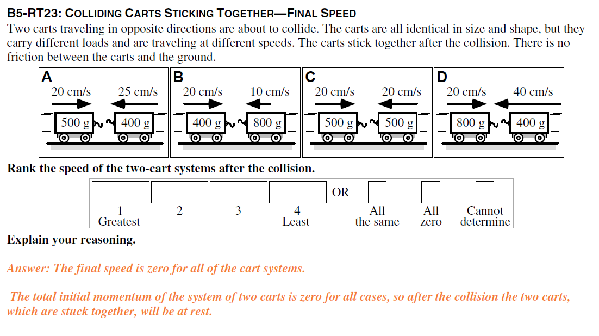

## nT7D-RT18: Colliding Carts Sticking Together—Final Speed

In each of the six figures below, two carts traveling in opposite directions are about to collide. The carts are all identical in size and shape, but they carry different loads and are initially traveling at different speeds. The carts stick together after the collision. There is no friction between the carts and the ground.



Rank these situations on the basis of the speed of the two-cart systems after the collision.

Greatest 1 _______ 2 _______ 3 _______ 4 _______ 5 _______ 6 _______ Least

OR, The speed is the same but not zero for these two-cart systems after the collision. ___

OR, The speed is zero for these two-cart systems after the collision. ___

OR, We cannot determine the ranking for the speeds of these cart systems after the collision. ___

**Please explain your reasoning.**



## nT7D-CCT24: Colliding Carts That Stick Together—Final Kinetic Energy

Two identical carts traveling in opposite directions are shown just before they collide. The carts carry different loads and are initially traveling at different speeds. The carts stick together after the collision.



Three physics students discussing this situation make the following contentions:

Alex: “These carts will both be at rest after the collision since the initial momentum of the system is zero, and the final momentum has to be zero also.”

Belinda: “If that were true it would mean that they would have zero kinetic energy after the collision and that would violate conservation of energy. Since the right-hand cart has more kinetic energy, the combined carts will be moving slowly to the left after the collision.”

Chano: “I think that after the collision the pair of carts will be traveling left at 20 cm/s. That way conservation of momentum and conservation of energy are both satisfied.”

Which, if any, of these three students do you think is correct?

*Alex* _____ *Belinda* _____ *Chano* _____ None of them______

Please explain your reasoning.

