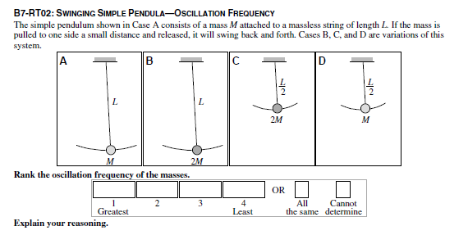
Answer: C = D > A = B.
The frequency is the inverse of the period or time for one complete swing. So the higher the frequency the smaller
the time. The period is independent of the mass of the bob and depends only on the length.

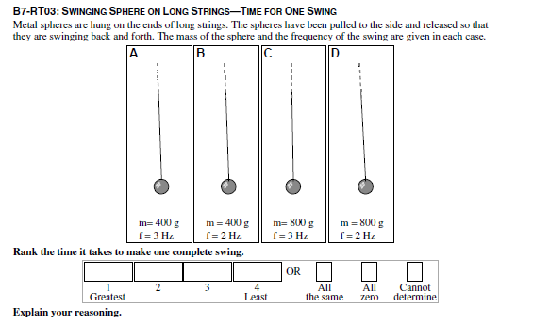
Answer: B = D > A = C.
The frequency is the inverse of the period or time for one complete swing. So the higher the frequency the
smaller the time. The period is independent of the mass of the bob.

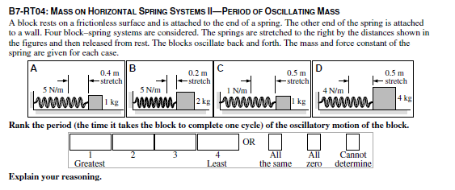
Answer: C = D > B > A.
The period is given by the square root of the mass divided by the spring constant. The period is independent of the
amplitude.

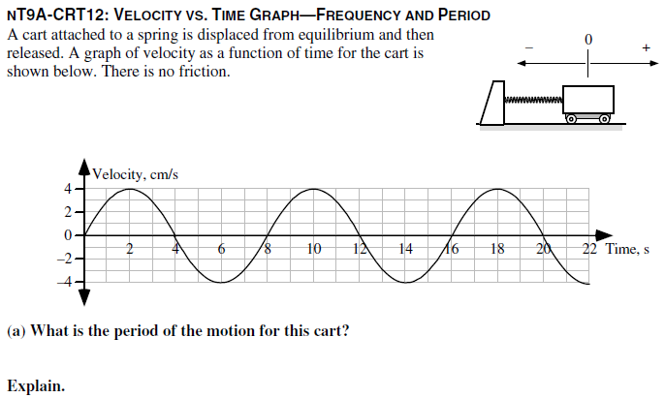
Answer: 8 seconds.
The period is the time for the complete cycle of the oscillation so we measure along the horizontal, time, axis
from the same point—peak to peak, or trough to rough, etc—on two successive cycles..

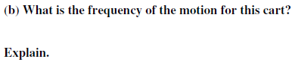
Answer: 1/8 Hz.
The period is 8 seconds from the graph. The frequency is the reciprocal of the period or
1/8 Hz.

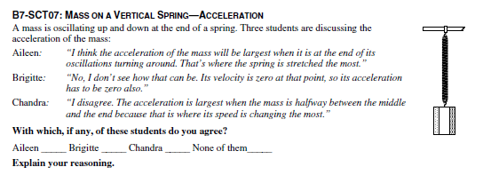
Answer: Aileen is correct.
Since maximum displacement is the point where the spring is stretched, or compressed, the most the force exerted
by the spring has to be largest there.

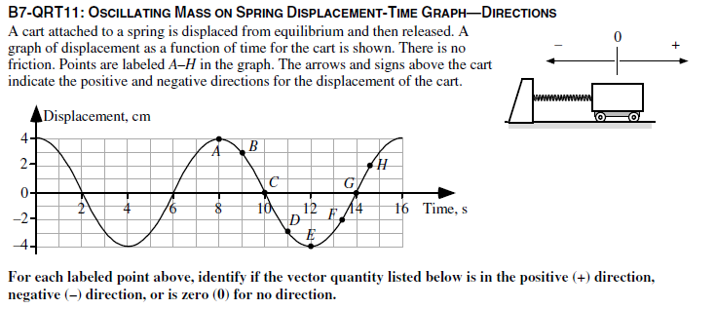
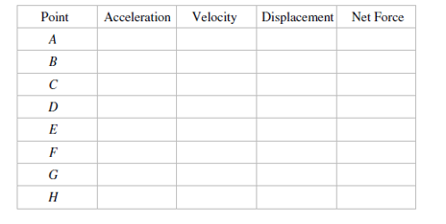
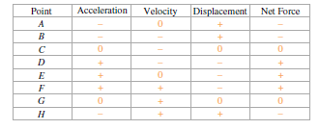
Explain your reasoning.
Answer: The signs for the displacement can be read from the graph. The velocity is related to the slope of the
graph at these points. The force exerted by a spring is always directed opposite to the displacement from
equilibrium. In this case, the spring force is the net force and the acceleration has the same direction as the net
force.

7.
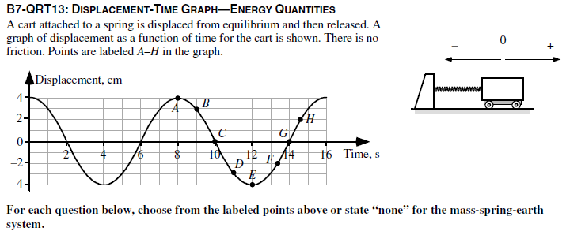
- At which point or points are the spring potential energy and the cart’s kinetic energy both at their maximum values? Explain your reasoning.
None.
The spring potential energy and the cart’s kinetic energy always add up to the total energy, which is constant. So
if one is at a maximum value, the other is at a minimum value.
- At which point or points is the kinetic energy equal to aero? Explain your reasoning.
Points A and E.
The slope of the graph is zero at these points indicating zero velocity.
- At which point or points is the total energy at its maximum value? Explain your reasoning.
A, B, C, D, E, F, G, and H.
The total energy is always the same.
- At which point or points is the spring potential energy negative? Explain your reasoning.
None. The spring potential energy is proportional to the square of the distance the spring is stretched or
compressed, and is always positive or zero.

- At which point or points is the kinetic energy positive? Explain your reasoning.
Points B, C, D, F, G and H.
The kinetic energy is always either positive or zero.
- At which point or points is the kinetic energy at its maximum value and the spring potential energy at its minimum value? Explain your reasoning.
Points C and G.
When the cart is in the equilibrium position the spring is unstretched and there is no spring potential energy. At
these points the kinetic energy of the cart is equal to the total energy.

- At which point or points is the kinetic energy at its minimum value and the spring potential energy at its maximum value: Explain your reasoning.
Points A and E.
When the cart is at its maximum displacement the cart is momentarily at rest and the kinetic energy is zero.

