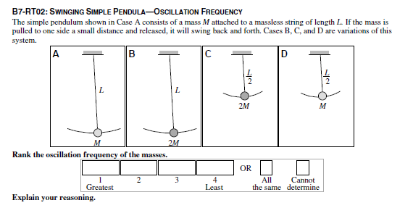

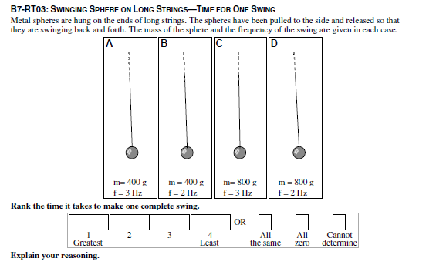

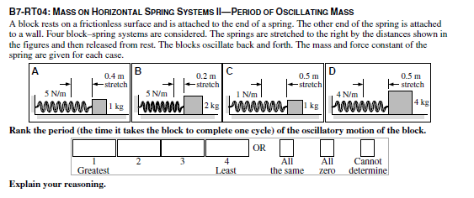

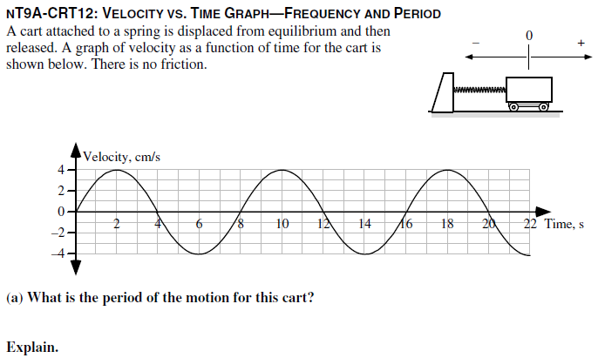

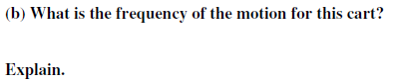

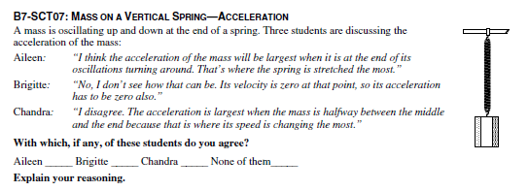

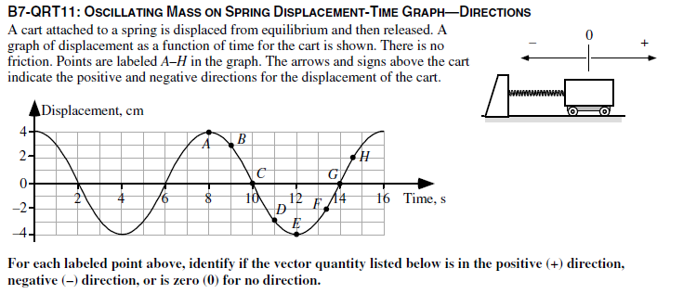
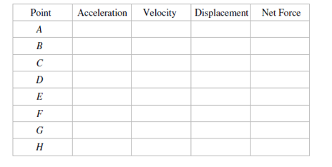

7.
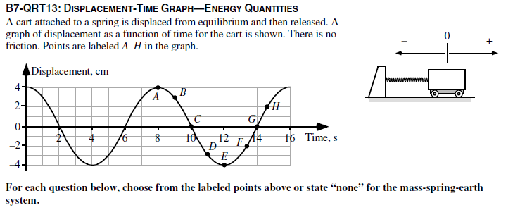
- At which point or points are the spring potential energy and the cart’s kinetic energy both at their maximum values? Explain your reasoning.

- At which point or points is the kinetic energy equal to aero? Explain your reasoning.

- At which point or points is the total energy at its maximum value? Explain your reasoning.

- At which point or points is the spring potential energy negative? Explain your reasoning.

- At which point or points is the kinetic energy positive? Explain your reasoning.

- At which point or points is the kinetic energy at its maximum value and the spring potential energy at its minimum value? Explain your reasoning.

- At which point or points is the kinetic energy at its minimum value and the spring potential energy at its maximum value: Explain your reasoning.

