Name: ___________________________________________ Date:___________________________
Mechanical Waves- Waves on String Lab (Phet)

Objective: Explore the properties of transverse and longitudinal wave.
Part 1: Exploring amplitude and compressional waves
Background video: https://www.youtube.com/watch?v=RVyHkV3wIyk

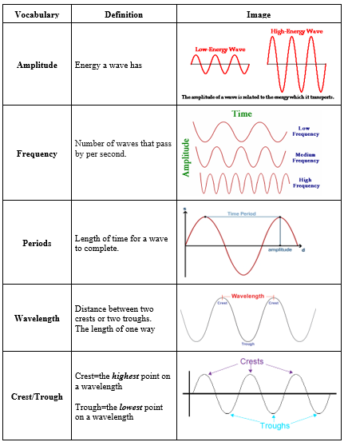

Waves on a String Lab Name: _____________________ Period: ____
https://phet.colorado.edu/sims/html/wave-on-a-string/latest/wave-on-a-string_en.html

Set up the Simulation
v = f λ
- Go to Schoology and open the Waves on a String Simulation on your iPad
- Set the simulation to Oscillate (top left)
- Set the simulation to No End (top right)
- Set damping slider to None and tension slider to High (bottom middle)
- Check the box for Rulers (bottom right)

Describe
Click the “Oscillate” button. Describe what is happening
Description
Drawing

Data
Measure wavelength and calculate speed in the table below. Move the Frequency and Amplitude sliders to the numbers listed in each row. Let the wave run for a few seconds and then pause the waves and use the ruler to measure the wavelength. Record your wavelength and use that value along with the frequency to calculate speed (leave in cm for this)
Amplitude | Frequency | Wavelength (cm) | Speed (cm/s)
0.75 cm | 1.50 Hz
1.25 cm | 1.50 Hz
0.75 cm | 2.10 Hz
1.25 cm | 2.10 Hz
0.75 cm | 3.00 Hz
1.25 cm | 3.00 Hz

Analysis Questions
- How does changing the Frequency affect the wavelength? (may use illustrations to help explain)

- How does changing the Amplitude affect the wavelength?

- How does changing the Frequency affect the wave speed?

- How does changing the Amplitude affect the wave speed?

- If you lower the frequency of a wave on a string you will

  - Lower its speed
  - Increase its wavelength
  - Lower its amplitude
  - Shorten its period

6. _____ What is the relationship between the amplitude of a wave and its speed?
- The amplitude of a wave is independent of its speed.
- The amplitude of a wave is directly proportional to its speed.
- The amplitude of a wave is directly proportional to the square of the inverse of its speed.
- The amplitude of a wave is directly proportional to the inverse of its speed

7. Consider this wave approaching a fixed end ______ Which shows the wave after it reflects?
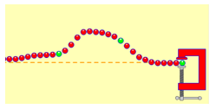

The Bounce
- Set the simulation to Pulse (top left)
- Set the simulation to Fixed End (top right)
- Keep damping slider set to None and tension slider set to High (bottom middle)
Describe with words or drawings what happens when the wave makes it to the other end of the string:

Standing Waves
- Keep the simulation set to Oscillate (top left)
- Keep the simulation set to Fixed End (top right)
- Keep damping slider set to None and tension slider set to High (bottom middle)
- Set Amplitude to 0.10 cm
- Set Frequency to 1.30 Hz
# of Standing Waves: |  | Draw a picture of the standing waves formed:
# of Wavelengths:

6. Draw a compressional (longitudinal) wave and label the rarefactions and compressions

