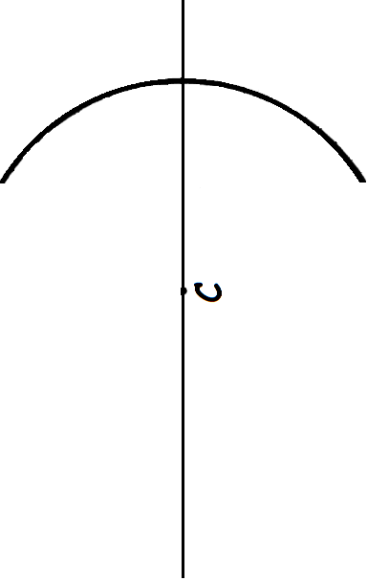

**Part D - Blank Curved Mirror Diagram**



**Part D - Blank Curved Mirror Diagram**