Match that Graph!
In today’s activity, you will be matching and creating position vs. time and velocity vs. time graphs for several different scenarios.
If you are given a graph…
- You must describe the motion that was made to match it using the motion sensor
- You must create the corresponding velocity vs. time graph
If you are given a description…
- You must predict the position vs. time and velocity vs. time graphs that the motion will create
- You must write down how the actual graphs look
Scenarios:
A B C
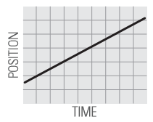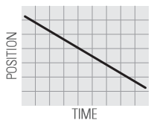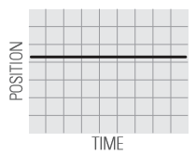
D E F
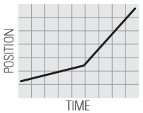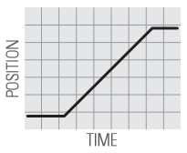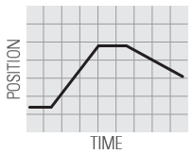
G- walk slowly toward the sensor, then faster away from the sensor
H- begin at rest for 2 seconds, walk fast toward the sensor, stop for 2 seconds, walk away from the sensor at the same speed
I- walk fast away from the sensor, then slower away from the sensor
J- walk toward the sensor, stop for 2 seconds, walk away from the sensor slower, walk toward the sensor faster than before

