Inquiry and use of the Scientific Method
On a SEPARATE paper, write the provided problem and then complete all the following steps.
Problem/Question: How can I tell how fast my marble is going?
Background Resarch: What do you think velocity depends on?
Hypothesis: Prior to releasing the marble, what is your answer to the problem/question?
Observations: What did you observe?
Procedure: Choose a fixed ramp height and record.
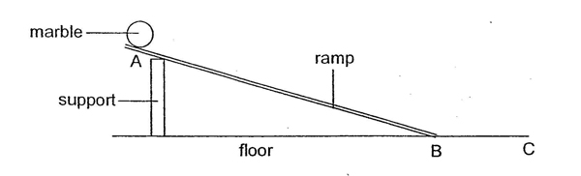
(Sample Data YMMV)
Position
0m .3m .6m .9m .11m
______________________________ C
0s 1s 2s 3s 4s
Time
Record time with respect to distance from point B to point C where the marble is roughly constant. Try to attain five data points.
Data: Now that you have the procedure, you must create a data table so that you can record data.
- Title the data table
- Label each column with variable measured and unit of measure
Analysis:
Create a Ticker tape diagram for your run using the large sheets of paper.
Create a Distance vs time graph
- What does your data show?
- Do you notice any trends or patterns?
- Create a graph from the data
Conclusion: Read the problem/question again. What do you think?
- Was our hypothesis supported?
- Explain what you can infer from the data.
- Explain what you can infer from the graph.

Sample Ticker Tape.
The object is represented by the dot.

Place your ticker tape diagram below:

Graph:

Analysis Cont:
Label the graph Independent Variable, Dependent Variable, Title, and units. Include proper scaling.

Slope of Line=____________________ Units___________ What does the slope tell you?

