Name:____________________________________ Date:_______________________ Pd:_________
…the Need for Speed!
Introduction

Although you may never have given it much thought to walking from one place to another, you were actually observing some basic physics concepts…you were in motion. Motion is movement from one location to another in a certain amount of time and in a given (or particular) direction. In this activity you will take measurements of your motion and use those measurements to describe your motion and determine relationships between different moving objects.

Materials

Stopwatch or phone timer
small piece of masking tape
tape measure
5 small droppable objects

Procedure

- Find a location where you can walk straight for at least 15 seconds. Mark your starting point (piece of tape, chalk line, stick, etc.) on the ground.
- Getting ready for the walk…you will walk forward from your starting point in a straight line. You will need to drop one droppable object at each 3-second interval (every 3 seconds) You can use a stopwatch or just count off the 3 second intervals (one Mississippi, two Mississippi, etc…) for a total of 15 seconds.
- Ready...Set...Walk! (in a straight line)
- Measure the distance from the start to the first dropped object. This is the interval displacement from 0 – 3 seconds. Write this “Interval Displacement” in the data table #1 provided (in the box to the left of the arrow).
- Measure and write down the “Interval Displacement” between each dropped object (same process as step # 4) (3–6 s; 6-9 s; 9-12 s; 12-15 s).
- For Data Table 2: this is cumulative (the distances added together)

***Have your teacher approve Data Table #1***
Data Table #1 |  |  | Data Table #2  Cumulative Data (data added together at each time interval)
Time interval (s) | Interval  Displacement (m) |  | Total Time (s) | Total Distance from Start (m)
0 | 0 |  | 0 | 0
0 - 3 |  |  | 3
3 - 6 |  |  | 6
6 - 9 |  |  | 9
9 - 12 |  |  | 12
12 - 15 |  |  | 15

Analysis

- In meters, calculate your total distance travelled from the start to each dropped object separately…(start to 1st drop….start to 2nd drop…start……etc..)

- Enter your data from Data Table #2 in the class Data Table #2 form…click on link below:

- Calculate the average speed for your entire walk. Show your work. Avg speed = total distance/total time

- Choose 2 other class members from the class Data Table #2 and calculate who had the fastest average speed? The slowest average speed?

- How did you determine which person was fastest?

- Construct a distance v. time graph for your data as well as the two other class members you chose in #4 above. All data goes on the same graph. Draw a best fit line through each person's data points.
(SEE EXAMPLE BELOW)

- How does the graph show which person was the fastest and slowest?

- How does the slope provided by the best fit line on your graph compare to your average speed?

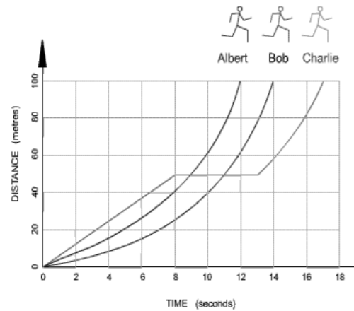
Example only!

You can use this graph or use the online program or find other graph paper
Time (seconds)
Distance (Meters)

