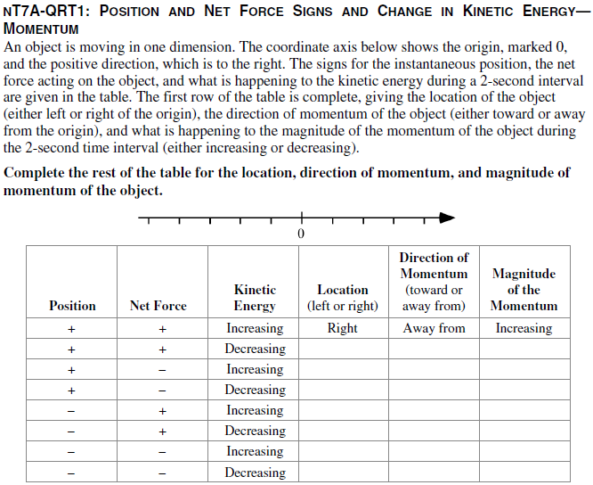

Answer When the object has a positive position, its location will be to the right of the origin, and when it has a negative position, its location will be to the left. If the net force acting on the object is in the same direction as its velocity, then its kinetic energy will increase; otherwise it will decrease. Based on the change in kinetic energy, the velocity (and therefore the momentum) is in the same direction as the net force in the first, third, fifth, and seventh cases. If the sign of the velocity is the same as the sign of the position, then the object is moving away from the origin, and the momentum direction is also away from the origin. Finally, because both the magnitude of the momentum and the kinetic energy are proportional to the speed of the object, when one quantity increases, so does the other.



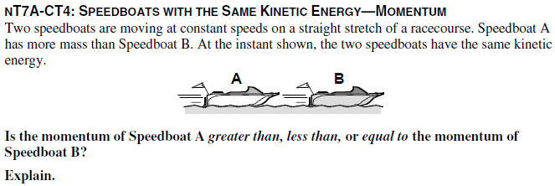

Answer: Speedboat A will have less kinetic energy than Speedboat B. The ratio of the speeds of the boats will be in the inverse of the ratio of the masses. In other words, if the mass of A is three times the mass of B, then the speed of B will be three times the speed of A. Since the speed is squared in calculating kinetic energy, if the mass were to remain the same and the speed were tripled, the kinetic energy would be nine times as great. In this case, the mass is one-third while the speed is tripled, so the overall kinetic energy will be 9 x 1/3 = 3 times as great.

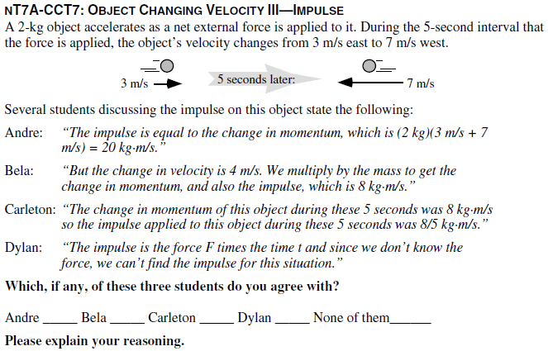

Answer: None of these students are entirely correct, but Andre is close. The change in velocity is the final velocity minus the initial velocity, or 10 m/s west. So the change in momentum is 20 kg•m/s west. Andre has the correct magnitude but has forgotten to include the direction of this vector quantity.

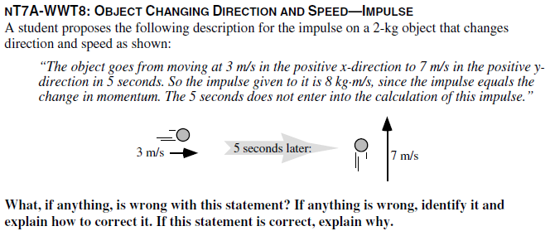

***Answer: The 8 kg******m/s is incorrect since the impulse and the change in momentum are vector quantities and this***

***description does not treat them as such. Using a coordinate axis with positive x to the right and positive y toward***

***the top of the page, the final momentum of the object is zero in the x-direction, so the change in momentum in***

***the x-direction is –6 kg******m/s. The initial momentum of the object in the y-direction is zero, so the change in***

***momentum in the y-direction is 14 kg******m/s. We can use the Pythagorean theorem to find the magnitude of the***

***change in momentum, which is 15.2 k******m/s. The direction of the change in momentum is 23.2 degrees to the left***

***of the positive-y axis.***

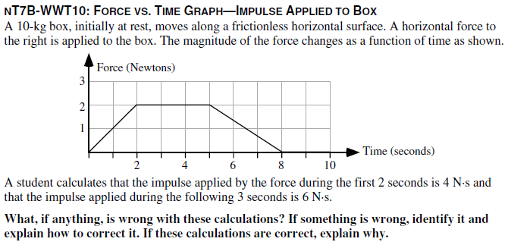

***Answer: The student’s calculations are wrong.***

***The impulse is given by the area under the curve which for the first two seconds is 2 N·s since (1/2)·2 s·2 N= 2***

***N·s. The student’s calculation for the next three seconds is correct.***

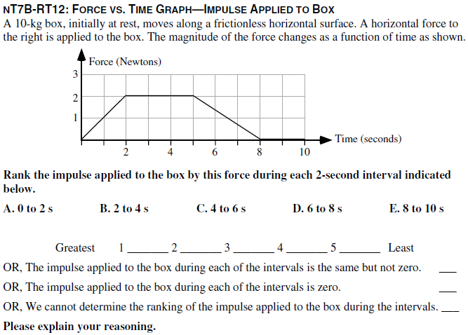

***Answer: B > C > A > D > E.***

***The impulse for each time interval is equal to the area under the graph during that time interval. From zero to 2***

***seconds this is 2 kg m/s; from 2 to 4 seconds it is 4 kg m/s; from 4 to 6 seconds it is 3.67 kg m/s; from 6 to 8***

***seconds it is 1.33 kg m/s; and from 8 to 10 seconds it is zero. (Note that you don’t really need to calculate values***

***as a visual inspection will enable one to rank the areas.)***