Simply Amazing:
Video clip:
https://www.youtube.com/watch?v=CGqp_cli9Ow

Is it Simple Harmonic Motion?
Video clip:
https://www.youtube.com/watch?v=gZ_KnZHCn4M
Follow the SHM Checklist!
It is SHM if…….
- Angle does not affect the period
- Sinusoidal motion
- F and x are directly proportional and oppositely directed
- Video clips: Foucault Pendulum
1. https://www.youtube.com/watch?v=se84vG6bzoA
2. https://www.youtube.com/watch?v=aMxLVDuf4VY
https://www.youtube.com/watch?v=iqpV1236_Q0
Simple harmonic motion or periodic motion?
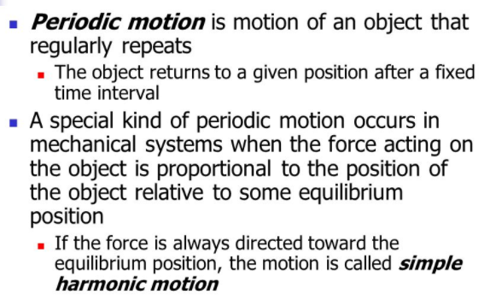
Video clip: TAKE NOTES AND SUBMIT VIA SCHOOLOGY
https://www.youtube.com/watch?v=tudxily5Qu0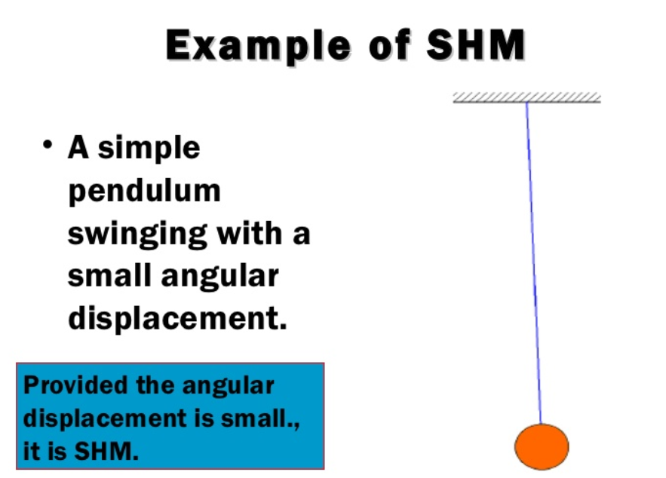

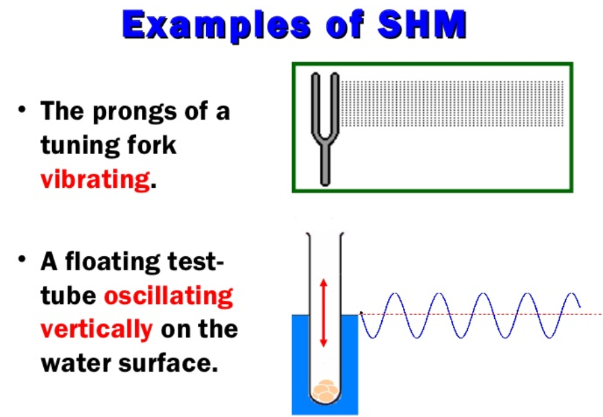
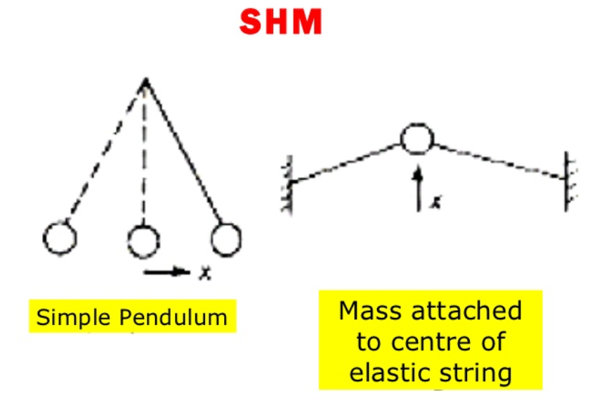
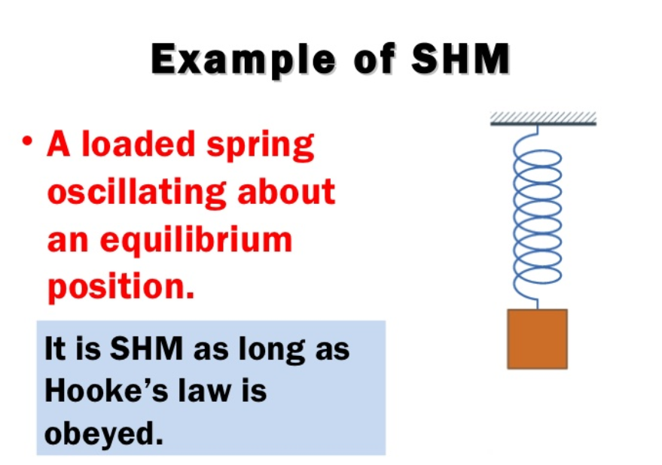
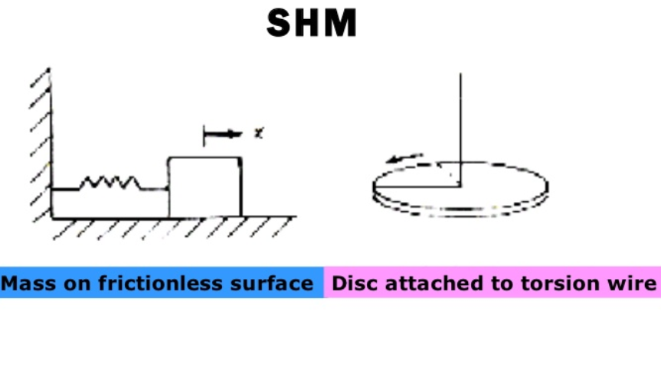
How can you recognize Simple Harmonic Motion from a Displacement vs Time graph?
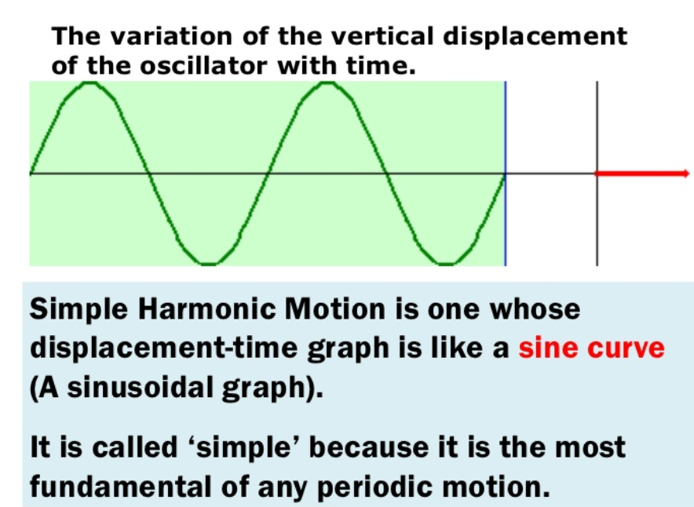
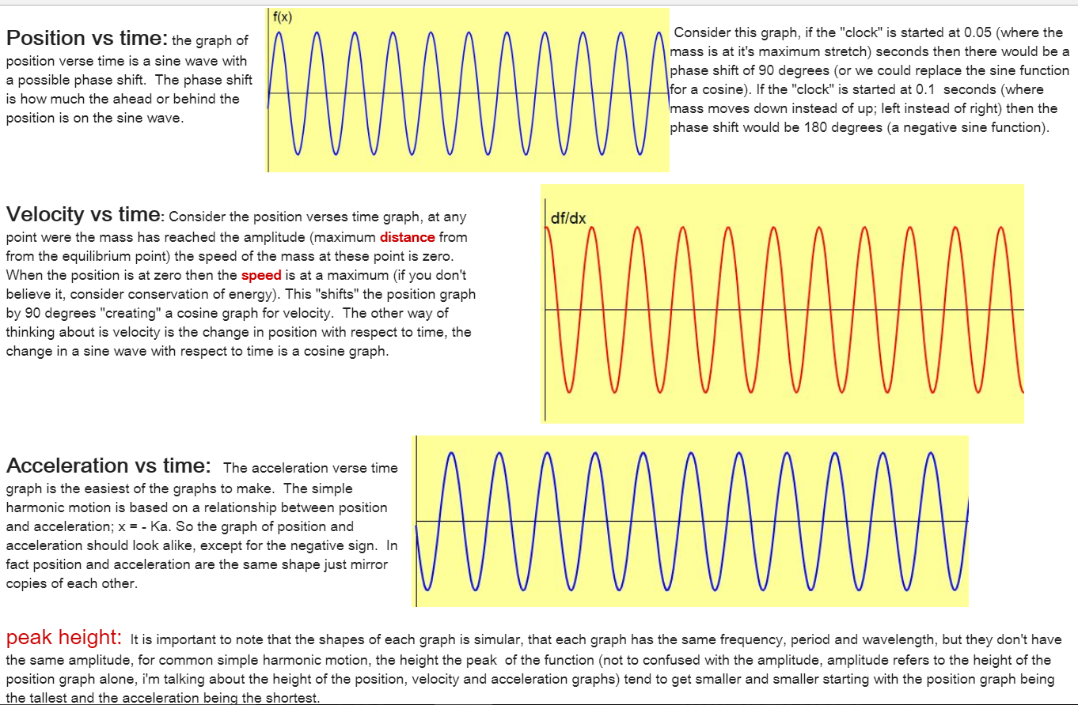
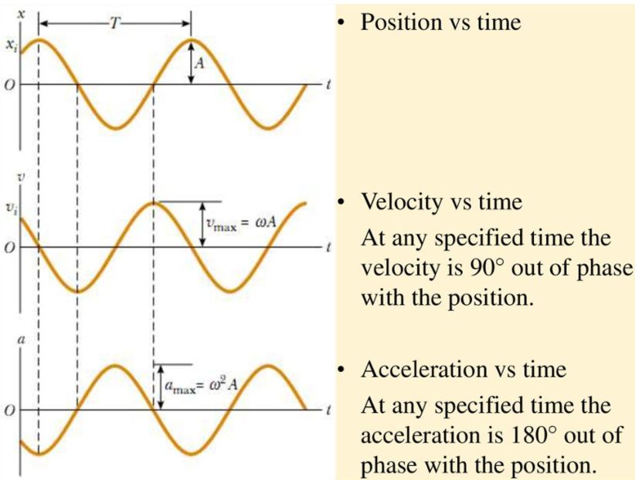

All periodic motion is not Simple Harmonic Motion.
Example Periodic but NOT Simple Harmonic Motion:
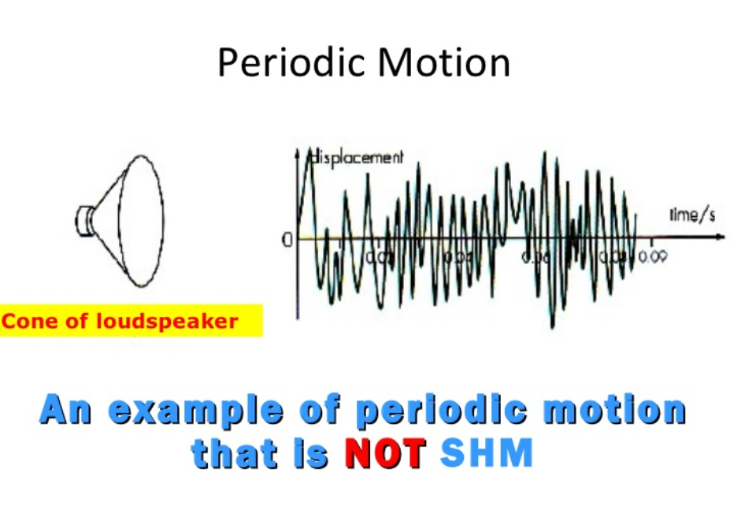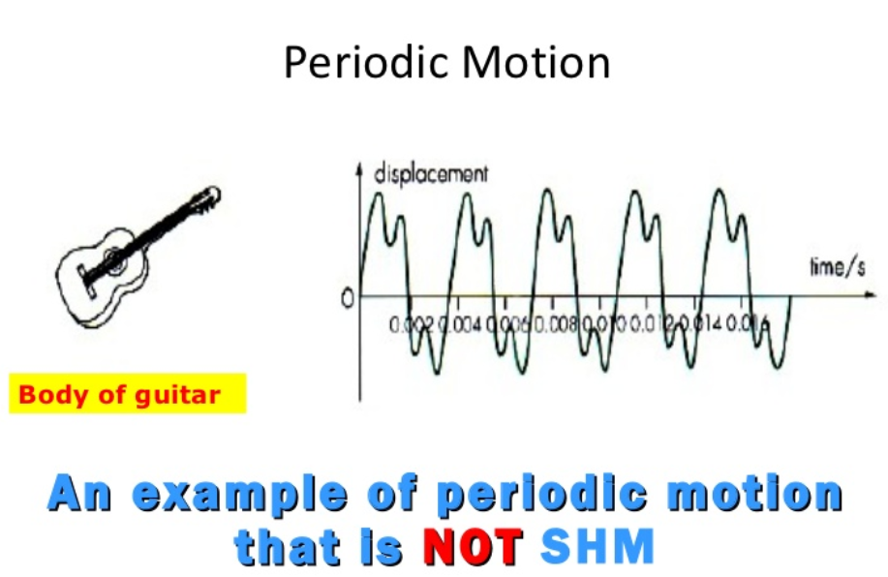

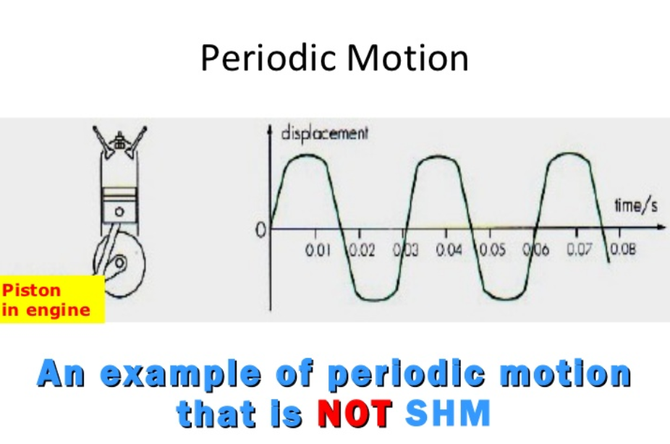

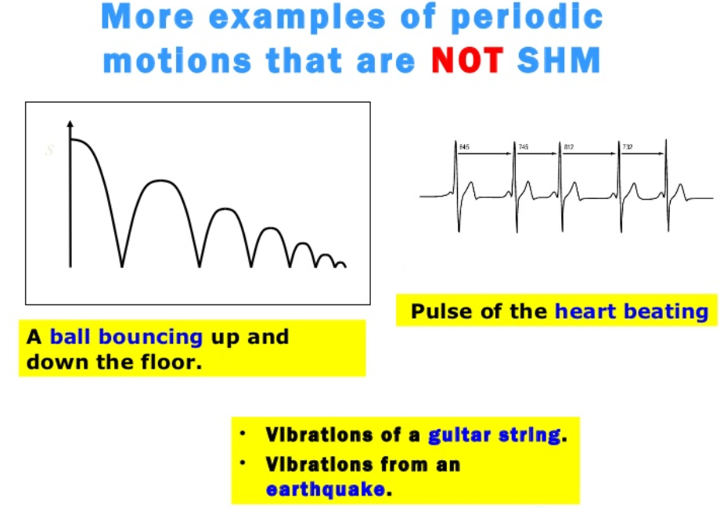

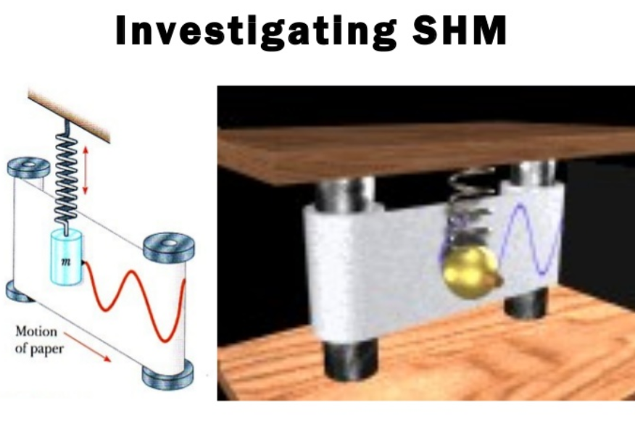
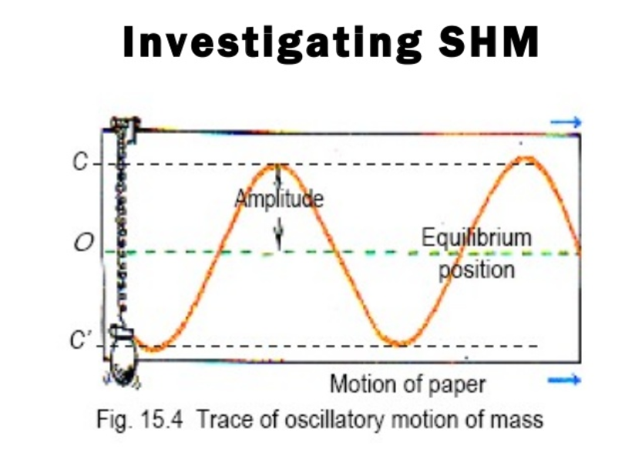
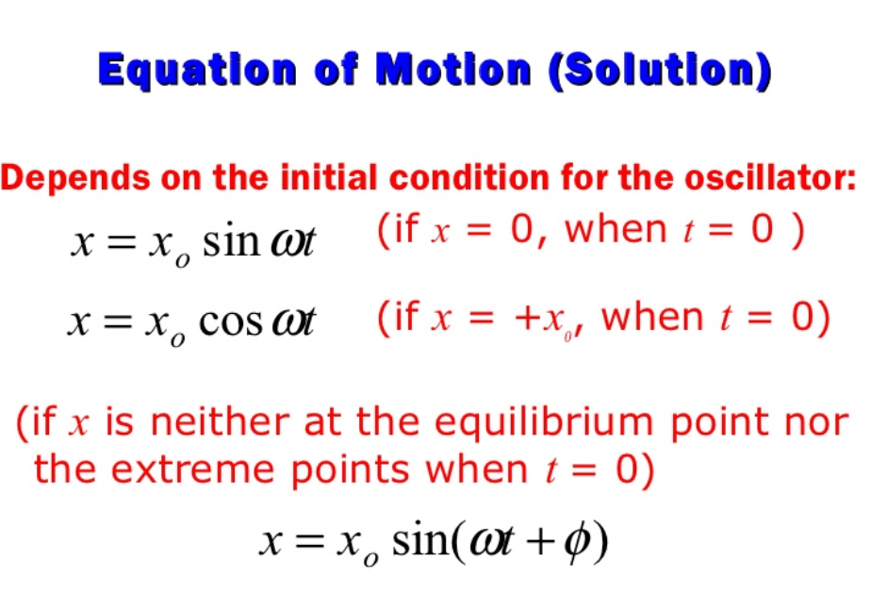
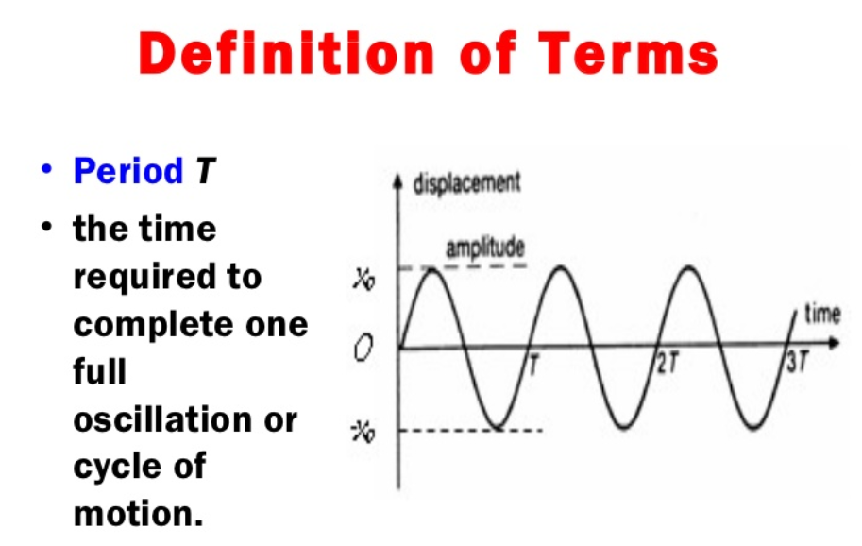
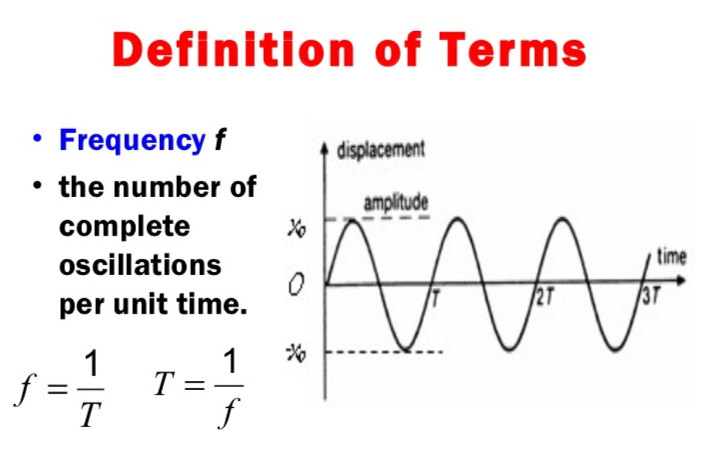
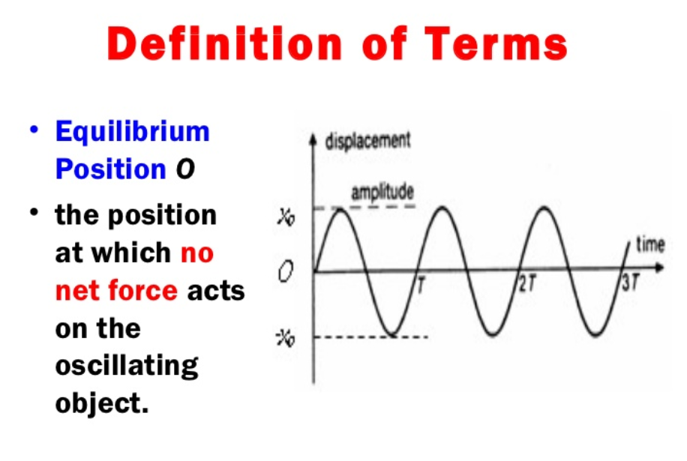
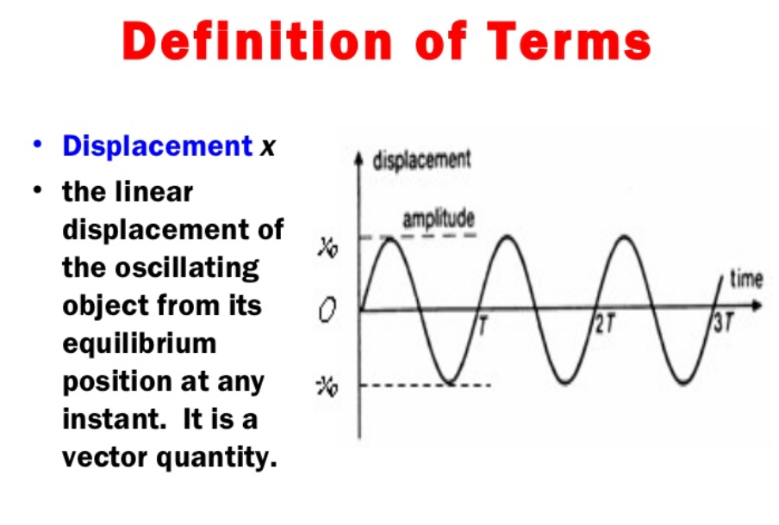
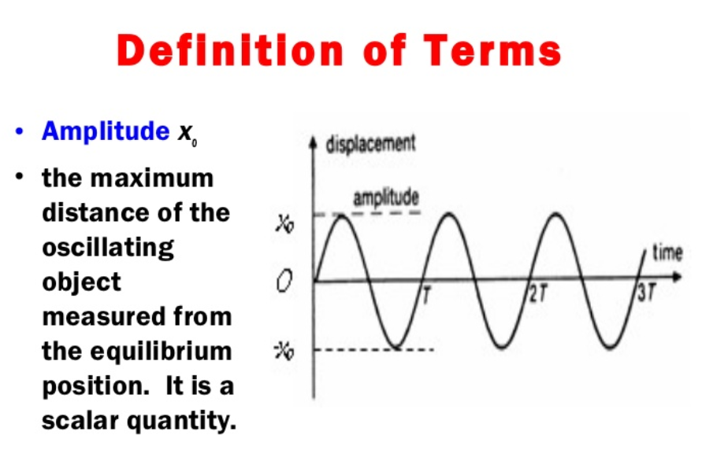
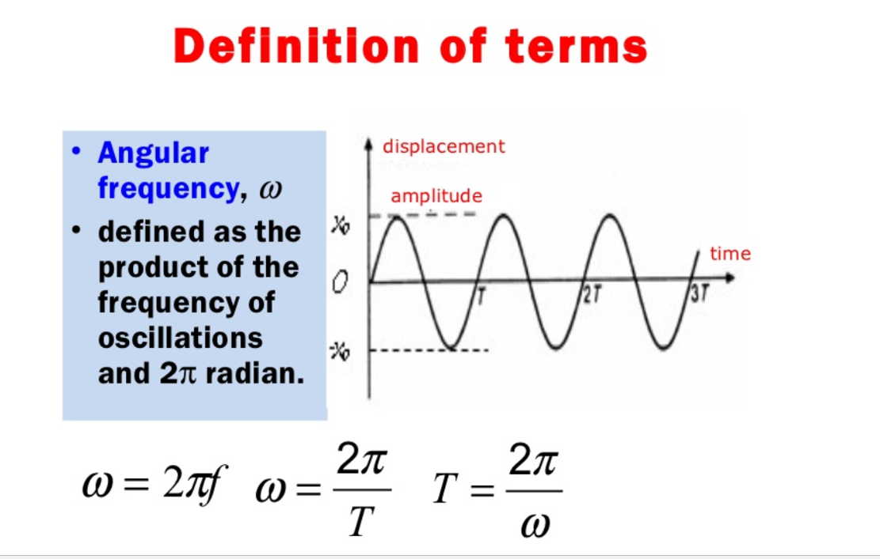
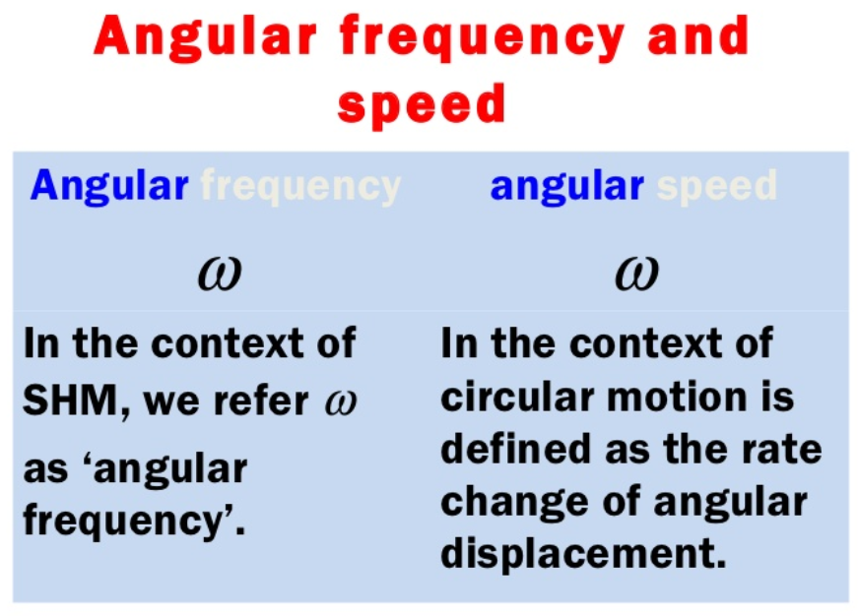
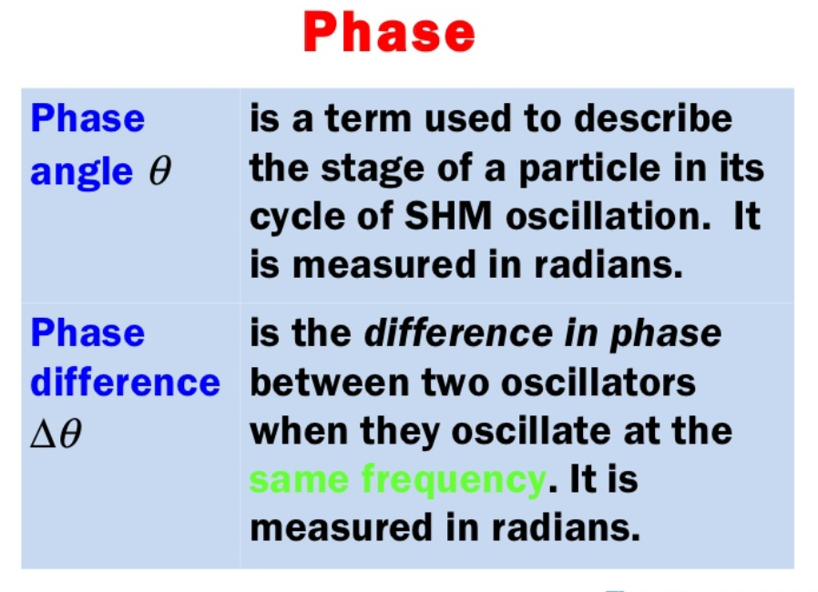
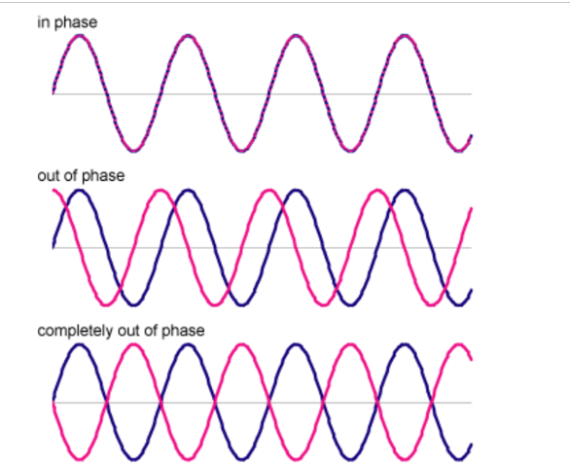

Periodic motion Example
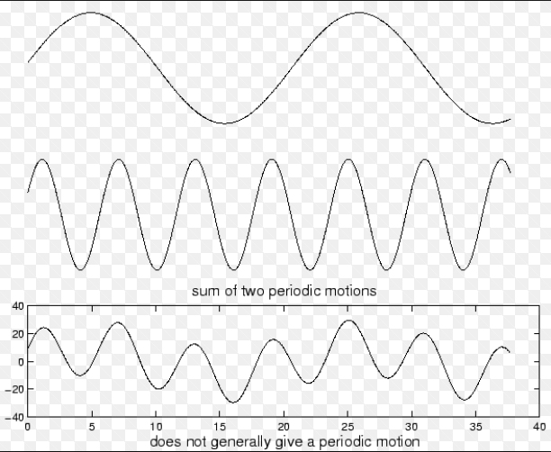
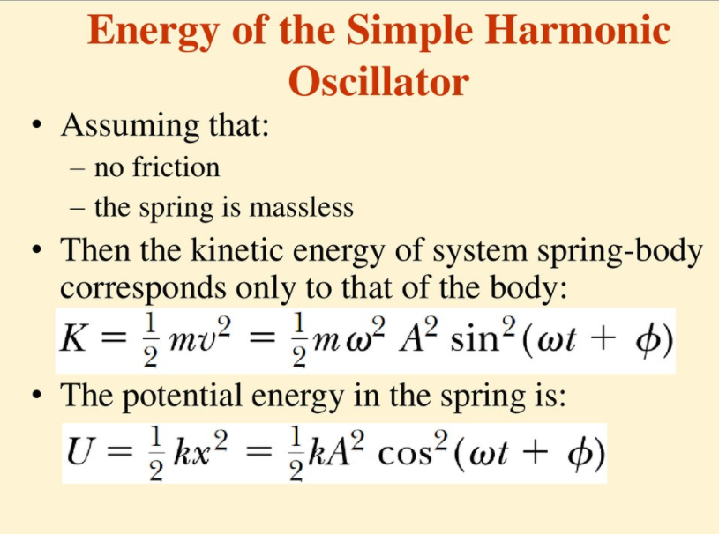
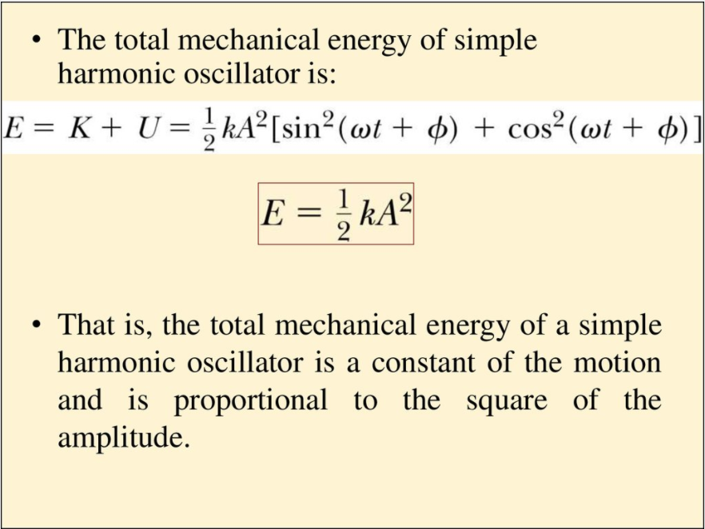

*Common Difficulties
- Students are easily distracted by the mathematics of oscillations. It is important to keep the mathematical models connected to graphs, pictures and demonstrations of real oscillating systems.
- Unfamiliar with radians
- Thinking that sin and cosine are two distinct functions rather than the same oscillatory function with a different phase constant
There is some vocabulary worth committing to memory here.
Simple Harmonic Motion serves as the model for many kinds of oscillations.
Mention: Torsional Pendulum, oscillations of a (saw blade) meter stick clamped at one end, vibrating machinery and oscillating circuits. Engines, electric machines (washing machine, earthquake).

- Five Easy Lessons -Knight

