Circular Motion Discovery lesson
Circular motion is a special case of motion in two dimensions. As we have seen, there are a few specialized variables to think about and different types of relative motion to consider. The activities included today are designed to help you discover some truths about the forces involved in keeping an object traveling in a circular path. Keep in mind that all of Newton’s Laws of motion still apply! Think critically about them as you do these demonstrations and answer the attendant questions.

Which Way Will It Go? Hoop and Ball Activity –
You will need a wooden hoop and a metal ball for this activity.
- Take the broken ring and a ball bearing and place them flat on the table.
- Stabilize the loop by holding it on the outside and place the ball inside near one side of the opening. Push the ball enough to make it roll around the inside of the ring and escape out the missing portion. Observe and record the direction it is traveling after it escapes.
- Draw a diagram of this activity as seen from above with a depiction of the ball in a couple of places along the ring including just after it escapes. Indicate with arrows the direction of the external forces acting on the ball in the positions noted in the diagram.
- What direction is the force (if any) on the ball while it is traveling in the ring? What about after it leaves? Write down the implications of this on the ball’s path once it leaves the ring referencing the appropriate Newton’s Laws.

What you think you feel – the Ball and String Activities
These next activities use a wooden ball on a fishing line and the PVC tube. You will need a pair of safety glasses and they will need to be on your face if there is anyone in the room doing this activity. In addition, get a line, ball and PVC tube. Make sure the ball is hooked securely on one end of the line, set the PVC aside for now.
- Hold the line with your fingers about 12 inches away from the ball and lay the loose end with the ball on a clear flat surface. Hold the rest of the string with your other hand up and out of the way above the table.
- Move your hand such that the ball begins to twirl around in a circle on the surface at a relatively constant speed – it does not have to be really fast!
- What force(s) in what direction(s) do you feel as a result of the motion?
- What happens if you let go of the string? What direction does the ball move? (does this remind you of anything you have seen recently?)
- What was holding the ball in its path before you let go? {note: “the string” is not the answer I am looking for!} Was there a force involved? What direction would it be directed in if there is one? Does this agree with the previous observation about the force on the string? If not, how might you explain this using Newton’s Third Law?
A further demonstration of the required force for circular motion

**In addition to wearing your safety glasses, please exercise caution in this part of the experiment as there will be lots of rapidly moving wooden balls around the classroom at approximately head height.

- Now unhook the ball from the line and thread the string through the short length of PVC tubing and re-hook the ball.
- Hook a small hanging mass to the spinner on the other end of the line. Record what this mass is as m₂.
- Hold the PVC vertically a little above your head with the ball side up and the hanging mass side down. Begin to move it in a small circle in order to make the ball twirl in a circle in the air. (see below) Experiment a little and find a condition at which the hanging mass is stationary.
  - What is notable about this speed?
  - In what direction is the force on the hanging mass?
  - In what direction is the force that keeps the ball moving in a circle?
  - What is the relationship between the two?
- Draw a diagram of this set up in your notes, denoting the major forces in play on the hanging mass and the ball.
- Determine the period (T= seconds/revolution) of the rotation and the length of the string (r in meters) on the “ball side” for two or three different speeds.
  - What do you notice about the length of the string and the position of the hanging mass at different speeds?
  - Write down the observed relationship between the radius and the speed.
T (s) | r (m) | Measured mass  m₁ =  m₂ =  Experimental m₁ =

- Set aside half a page or so and we will use the physics involved to calculate the mass of the ball (m1) from the measured T and r values you found.
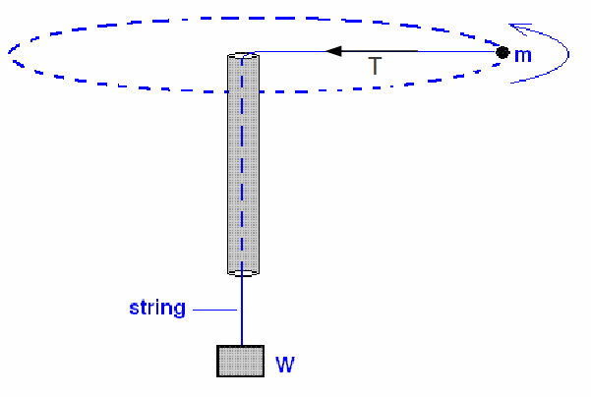

Whack-a-Ball – the game of incremental changes in velocity (Knight, 2004)
You will need a large open floor space, a bowling ball and a rubber mallet for this activity.
- Slowly but firmly roll the ball forward – the idea is to give it a slow but steady speed
- Try striking the ball with the mallet in such a way that the path of the ball describes part of a circle – in a tight space using a table leg as a visual reference for the center of the circle works well - see diagram below. If you have enough space try getting the ball to make a circle around a lab partner.
- Try it until you are able to get the ball to curve in a reasonable imitation of part of a circle.
  - What direction did you have to hit the ball to get it to curve around? Draw arrows indicating the direction on a diagram of its motion.
  - Does this agree with the other observations of the force required for circular motion?

References
Knight, R. D. (2004). Five Easy Lessons : Strategies for Successful Physics Teaching. San Francisco: Addison Wesley.

Notes about the lab to use during/after the slides reviewing the misconception questions.

Which Way Will It Go? Hoop and Ball Activity –
Newton’s first law is obeyed to the letter by objects traveling in a circular path –
The incomplete loop and ball bearing shows this – spinning the ball and string also shows this
Implications: the direction of the speed at any point on the circle (the velocity) is tangential – Therefore, by vector addition the change in velocity must point in what direction? {toward the middle} What is “change in velocity” synonymous with? {acceleration} If one is in the direction of the center, does the other have to be in the same direction? If there is acceleration must there also be a force that causes the change in V? {YES!}

What you think you feel - What direction is the net force?
Ball and PVC activity shows this graphically – so would a bowling ball and mallet
Draw the diagram, label the forces, define coordinate systems
Equate the F_{tension} for both FBD’s F_{Tweight} = F_{Tball}
F_{Tweight} = F_{g} = m₂g
F_{Tball} = F_{C} = m₁ V_{T}²r and V_{T} = 2Πr
T
Substitute and solve for m₁ to find the experimental mass of the ball
How close was it to the measured value? What might be the sources of error.
Implications: the force required to maintain a circular path MUST be directed toward the center of the circle.
In this experiment does the Fc change?

